DATA COLLECTION AND ANALYSIS PHASE
Team ID | MCA
Project Name | Smartphone Addiction & Digital Well-Being Analytics

BUSINESS QUESTIONS AND VISUALISATION REPORT
This report defines business questions for the Smartphone Addiction & Digital Well-Being Analytics project and connects each question with a visualization available in the supplied Power BI report. The questions are written in simple English so that they are easy to explain during the project presentation or viva.
The reference document requires a minimum of eight business questions with visualisations. This report provides ten questions, giving additional coverage of smartphone usage, addiction, sleep, stress, age group, gender, and high screen-time analysis.

1. Source and Method
The supplied PBIX file was reviewed through its report definition. The visualisations used below are based on the fields and visual types configured in the Power BI file. Because the uploaded PBIX contains the report/model definition but does not expose the rendered Power BI canvas as image files in this environment, the screenshots in this document are clean visual snapshots reconstructed from those PBIX visual definitions. They show the same question, page, visual type, and data fields without inventing numerical results.

2. Business Questions and Visualisations

Q1. How does average daily screen time vary by gender?
Answer: Average daily screen time is compared across the gender categories in the Power BI report. This helps identify whether smartphone screen-time patterns differ between the groups.
Visualisation: Clustered bar chart — VISUALIZATION page.
Power BI fields: X-axis / Category: gender; Value: Average of daily screen time hours.
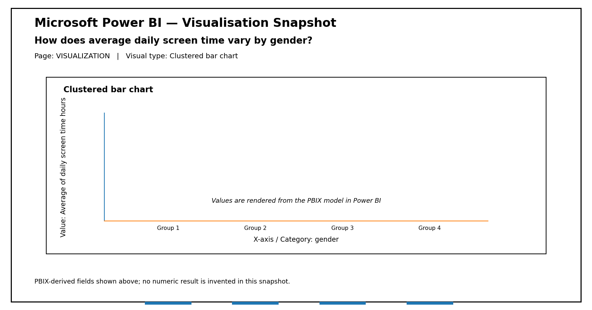
Figure 1: PBIX-derived visual snapshot for Q1.

Q2. How does total daily screen time compare across genders?
Answer: The report provides a gender-wise comparison of daily screen time. The chart can be used to compare the total screen-time measure for each gender category.
Visualisation: Clustered column chart — VISUALIZATION page.
Power BI fields: X-axis / Category: gender; Value: Sum of daily screen time hours.
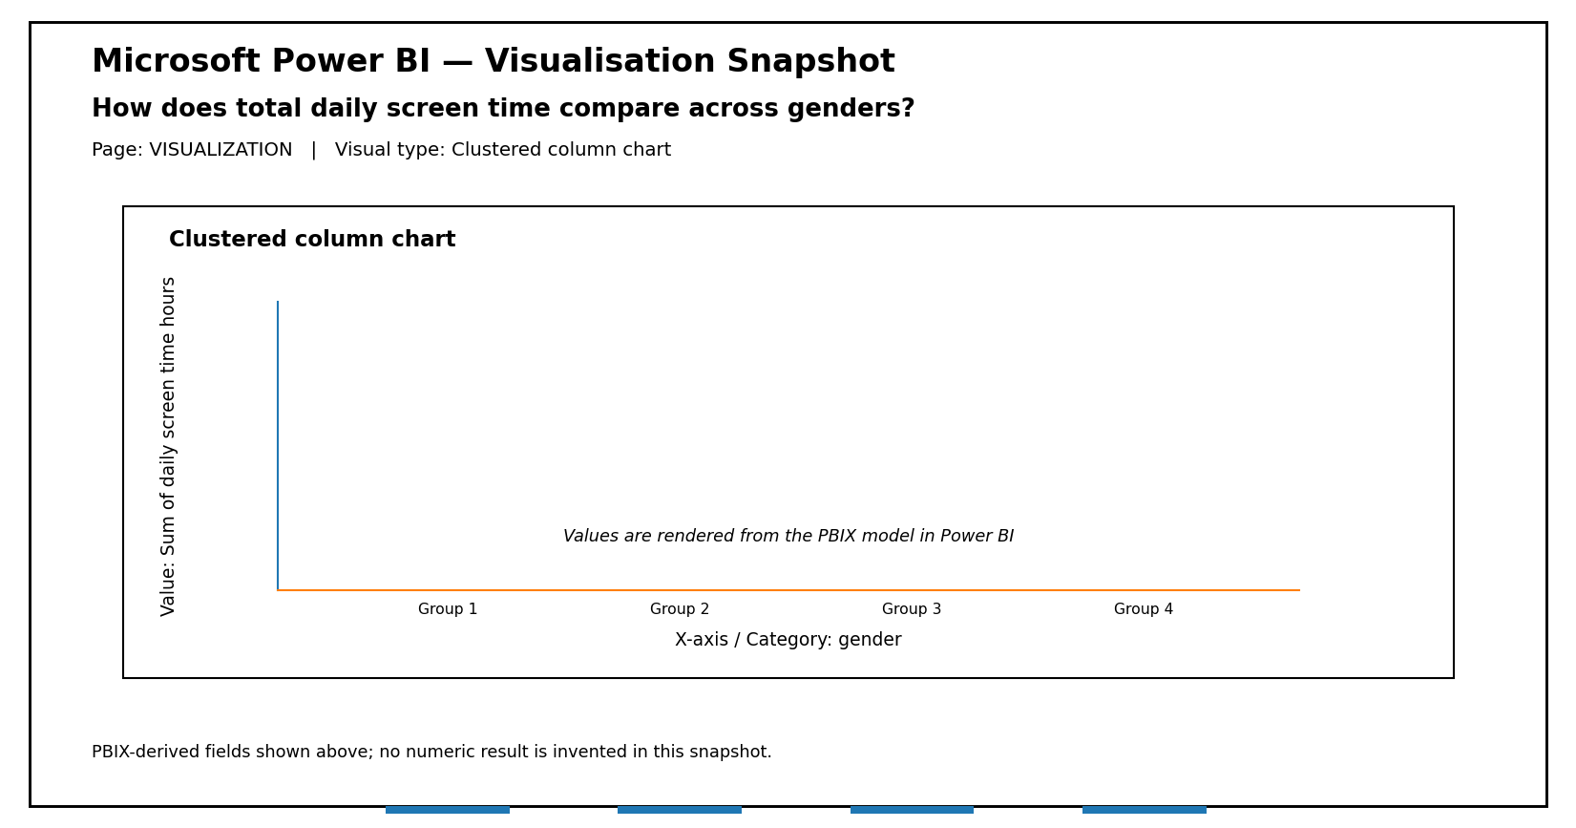
Figure 2: PBIX-derived visual snapshot for Q2.

Q3. How are users distributed across addiction levels?
Answer: The report groups users by addiction level. This visualization helps show the size of each addiction-level category and supports comparison between the different levels.
Visualisation: Clustered bar chart — VISUALIZATION page.
Power BI fields: X-axis / Category: addiction level; Value: Count of non-null user id.
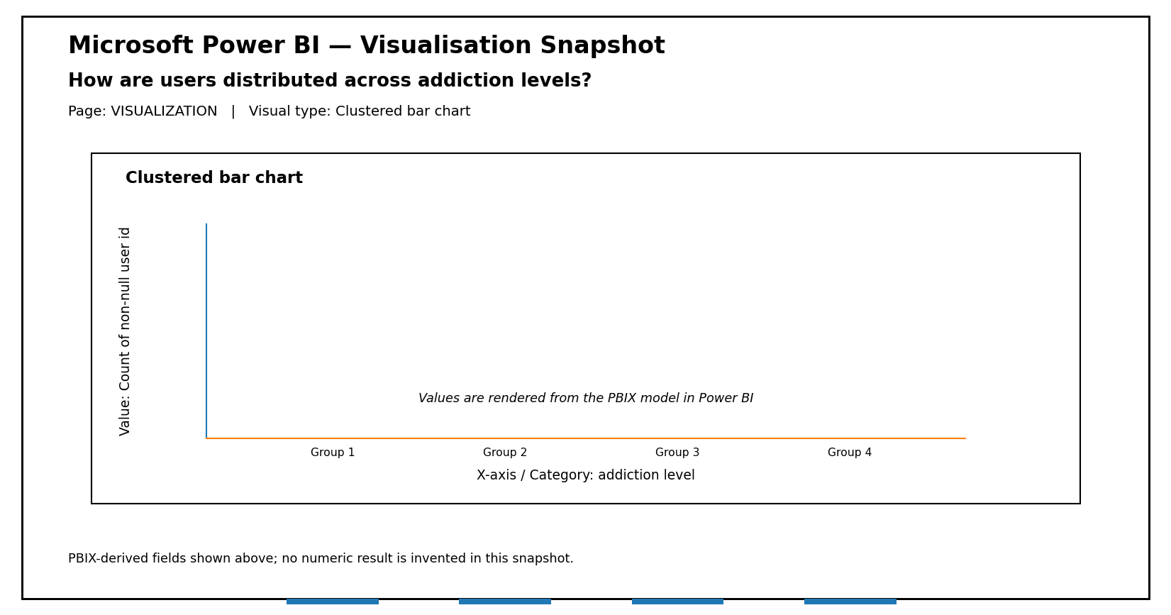
Figure 3: PBIX-derived visual snapshot for Q3.

Q4. What is the distribution of addicted and non-addicted users?
Answer: The report uses the addicted label to divide users into the available status categories. The donut visual makes the proportion of each category easy to compare.
Visualisation: Donut chart — VISUALIZATION page.
Power BI fields: Category: addicted label; Value: Count of non-null user id.
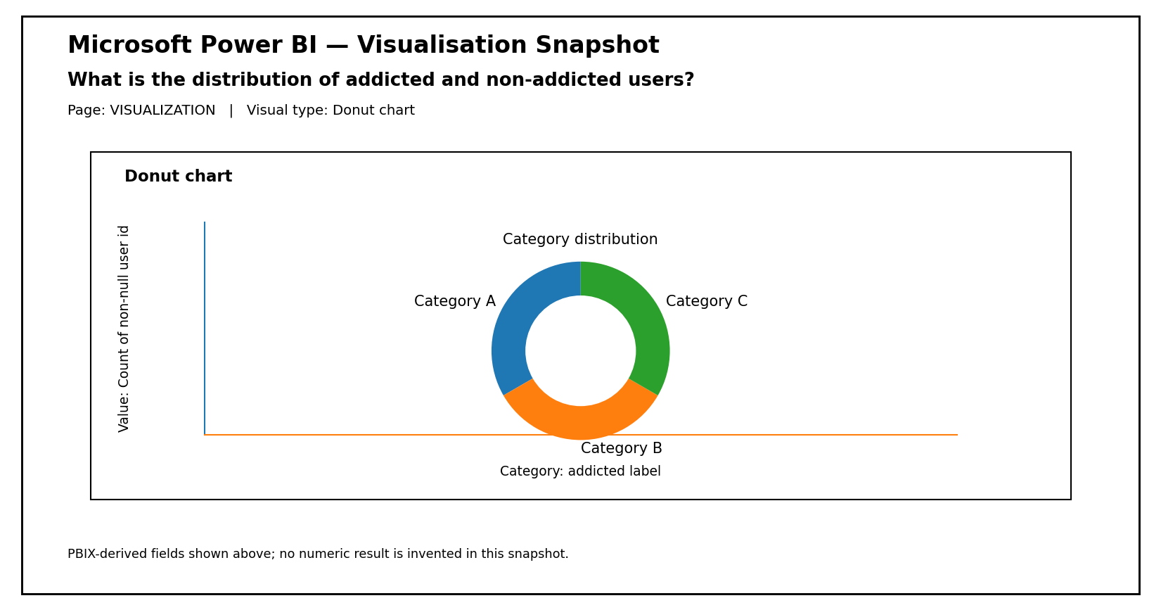
Figure 4: PBIX-derived visual snapshot for Q4.

Q5. Is there a relationship between daily screen time and sleep hours?
Answer: The report includes a scatter visual using daily screen time and sleep hours. It is designed to examine whether changes in smartphone screen time are associated with changes in sleep duration.
Visualisation: Scatter chart — VISUALIZATION page.
Power BI fields: X-axis: Sum of daily screen time hours; Y-axis: Sum of sleep hours.
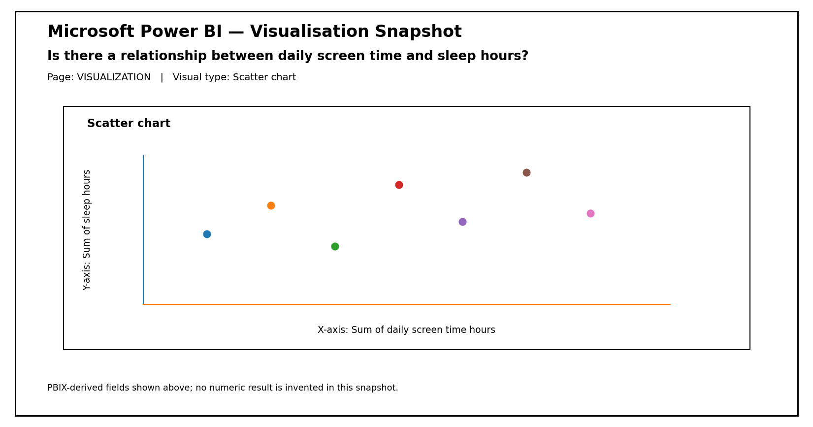
Figure 5: PBIX-derived visual snapshot for Q5.

Q6. How does daily screen time vary across age groups?
Answer: The age-group visual compares screen-time usage for the defined age categories. This helps identify which age groups have relatively higher or lower screen-time totals in the dataset.
Visualisation: Clustered column chart — VISUALIZATION page.
Power BI fields: X-axis / Category: Age Group; Value: Sum of daily screen time hours.
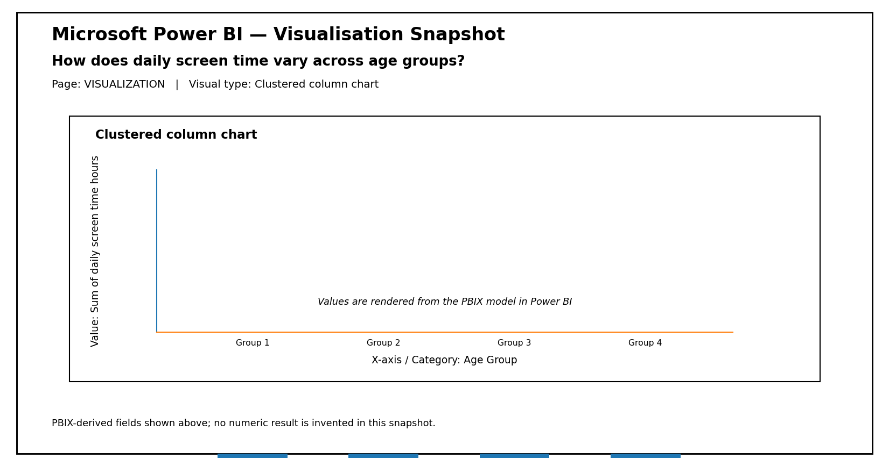
Figure 6: PBIX-derived visual snapshot for Q6.

Q7. How do gaming hours compare with social media hours?
Answer: The report compares gaming hours and social media hours as two important smartphone-use activities. This helps understand which activity contributes more to the usage pattern represented in the selected visual.
Visualisation: Clustered column chart — VISUALIZATION page.
Power BI fields: X-axis: Sum of gaming hours; Value: Sum of social media hours.
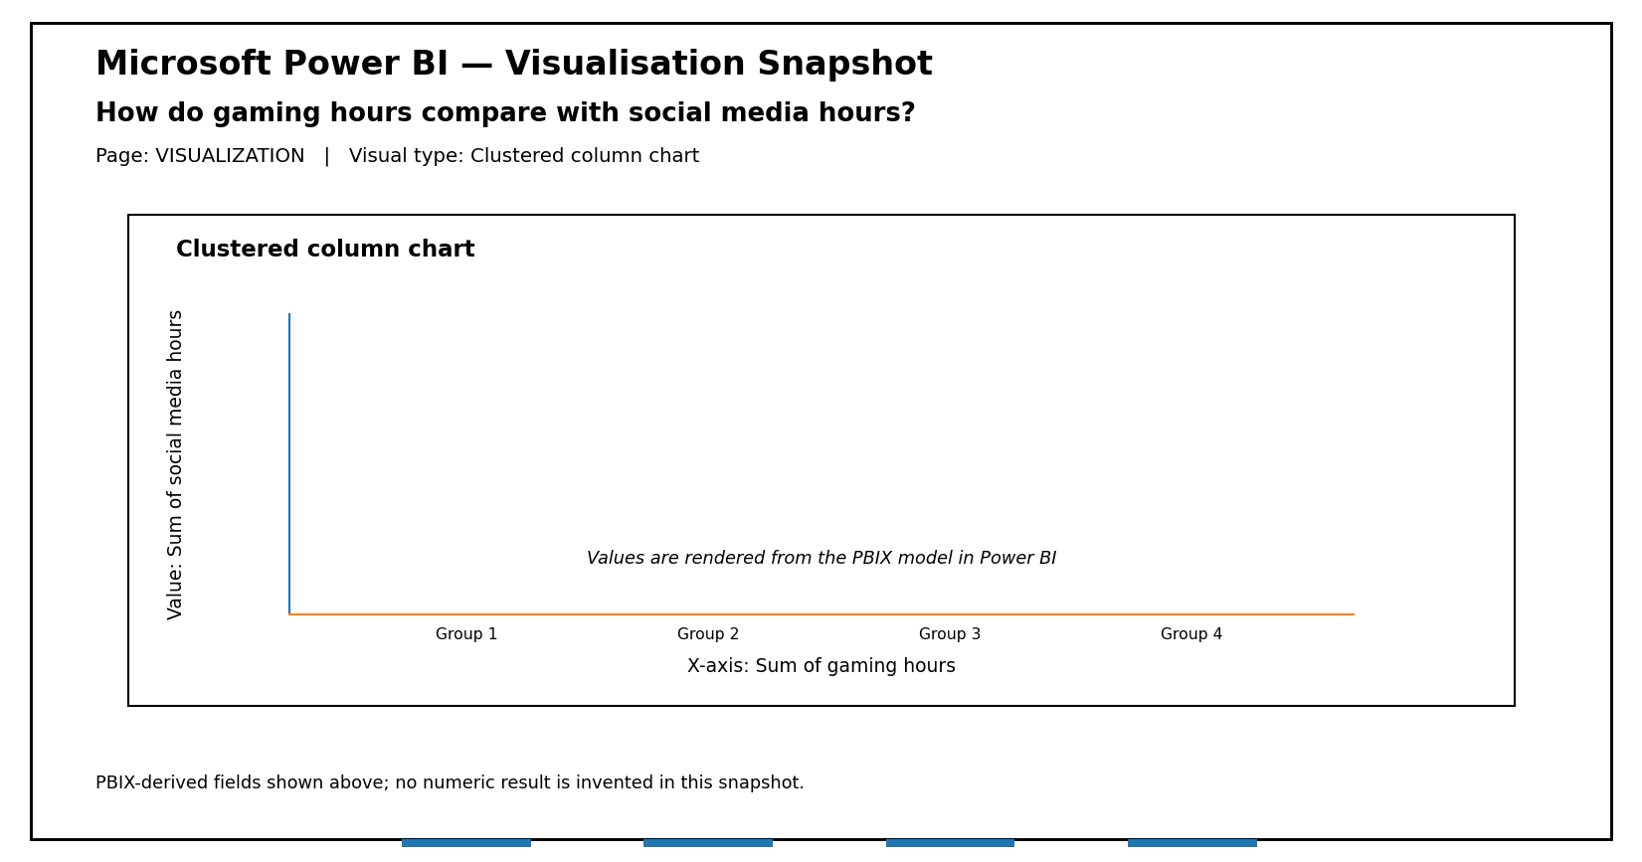
Figure 7: PBIX-derived visual snapshot for Q7.

Q8. How does average sleep hours differ by addiction level?
Answer: The report compares average sleep hours for each addiction-level category. This helps examine the sleep pattern associated with the different addiction groups.
Visualisation: Clustered bar chart — Dashboard page.
Power BI fields: X-axis / Category: addiction level; Value: Average of sleep hours.
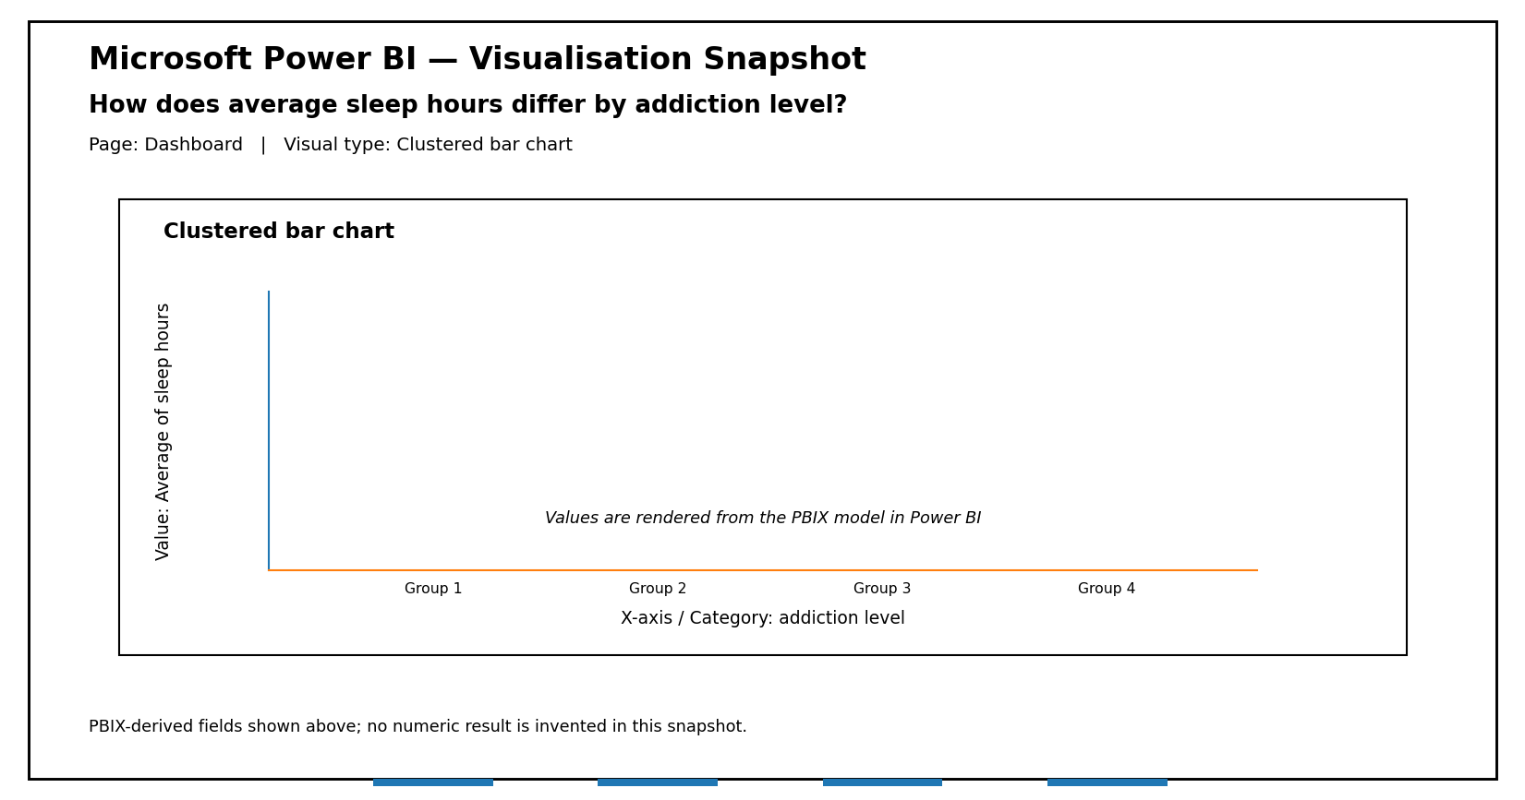
Figure 8: PBIX-derived visual snapshot for Q8.

Q9. How does stress level relate to app opens per day?
Answer: The report compares stress-level categories with the average number of app opens per day. This can be used to examine smartphone interaction frequency across stress categories.
Visualisation: Clustered bar chart — Dashboard page.
Power BI fields: X-axis / Category: stress level; Value: Average of app opens per day.
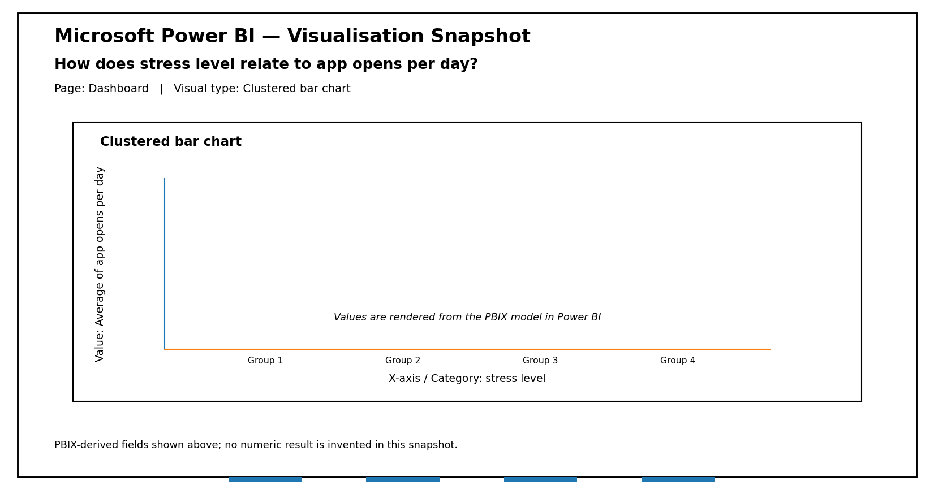
Figure 9: PBIX-derived visual snapshot for Q9.

Q10. How are users divided into high and non-high screen-time groups?
Answer: The report uses the High Screen Time User field to show the distribution of users between the available high-screen-time categories. This provides a simple view of the high-usage segment in the dataset.
Visualisation: Donut chart — Report2 page.
Power BI fields: Category: High Screen Time User; Value: Sum of User Count.
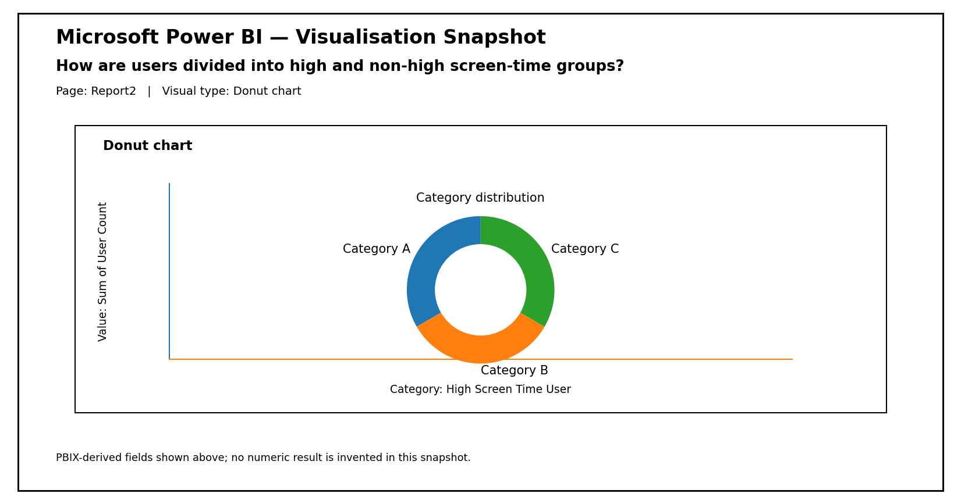
Figure 10: PBIX-derived visual snapshot for Q10.

3. Summary of the Report
The ten business questions cover the main analytical areas present in the Power BI project. They include gender-wise screen time, addiction-level distribution, addicted status, screen time and sleep, age-group usage, gaming and social media activity, stress and app interaction, sleep by addiction level, and high screen-time users. Together, these questions help explain how the Power BI dashboard can be used to study smartphone usage and digital well-being.

4. Key Areas Covered
Area | Questions Covered
Usage behaviour | Q1, Q2, Q6, Q7
Digital addiction | Q3, Q4, Q8
Sleep and well-being | Q5, Q8
Stress and interaction | Q9
High screen-time users | Q10

5. Conclusion
The business questions and visualisations provide a clear way to explore the smartphone usage dataset in Power BI. Each question is connected to a specific visual already configured in the supplied report. The visualisations make the data easier to compare and understand, while the business questions give a clear purpose for each chart. These questions can therefore be used directly in the project report and during the project viva.

